Chapter 18, Solution 47.

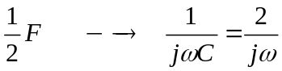

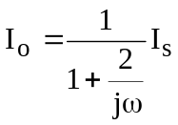
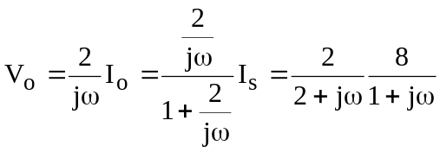

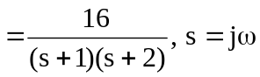

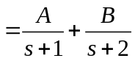

where A = 16/1 = 16, B = 16/(–1) = –16

Thus,
v_{o}(t) = 16(e^{–t} – e^{–2t})u(t) V.

